Dieselisation

The share of diesel cars in new registrations across the European Union (EU) increased from 23.5% in 1995 to 55.7% in 2011 (Association des Constructeurs Européens d'Automobiles, 2017[1]). A similar, albeit delayed, trend was also observed in the United Kingdom (UK), where diesel cars represented less than 20% of new registrations in 2001, with the market expanding to over 50% of new registrations in 2012 (Figure Y).

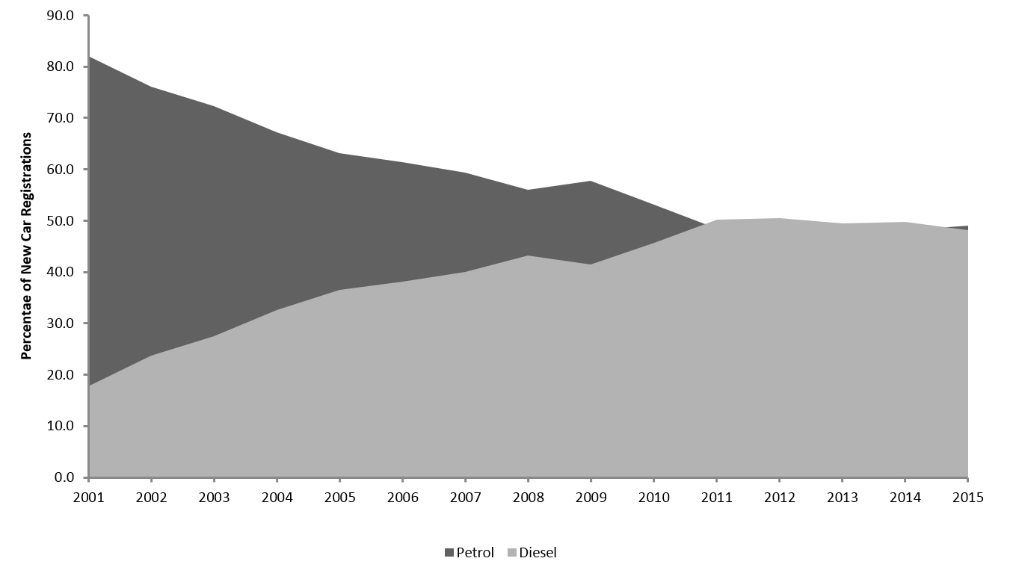

Schipper et al. (2002) offer a detailed description of the factors which facilitated this shift during the 1990s and attribute the rise in demand for diesel cars in Europe primarily to increased technical performance of diesel engines and beneficial taxation regimes. In terms of technical performance, the introduction of turbo and direct injection systems in diesel engines reduced a number of the comparative shortcomings (e.g. cold weather operation) and allowed diesel engines to penetrate a wider range of market segments (e.g. family hatchbacks). Moreover, diesel cars were capable of returning between 20% and 30% improved fuel economy as compared to an equivalent petrol. In terms of taxation regimes, diesel fuel was generally taxed to a lesser extent than petrol (except in the case of the UK), which when combined with the superior fuel economy of diesel cars, led to a situation whereby the fuel cost per kilometre travelled of diesel was between 54% and 80% that of petrol. Diesel cars also benefited from advantageous registration and circulation taxes in countries where these fiscal policies were aligned with carbon dioxide emission factors due to diesel cars generally achieving lower ratings on these factors as compared to equivalent petrol cars. Such a situation occurred in UK in 2001-02 (Mazzi and Dowlatabadi, 2007) and in Sweden in 2005 (Kågeson, 2013), with this change in taxation policy coinciding with a rapid expansion in the registration of diesel cars in those countries.

The widespread shift to diesel cars has a number of implications for society. Expectations were that increased penetration of diesel cars into national fleets would improve the energy efficiency and carbon dioxide emission factors of the stock, thus having benefits for energy security and climate change mitigation (Bonilla 2009; Tovar, 2011). However, these expected benefits have been eroded by increases to diesel car horsepower and mass (Zacharidis, 2013; Schipper and Fulton, 2009; Schipper and Fulton, 2013), with diesel cars sold in the EU-12 in 2009 being on average 48% more powerful and 24% more massive than those sold in 1995. This has been confounded by diesel cars continuing to be driven more than petrol cars, with Schipper and Fulton (2013) noting that average distance travelled in diesel cars across the EU-12 in 2009 was between 40% and 100% more than petrol. The shift towards diesel cars has simultaneously led to expansions in the quantity of local pollutants (e.g. particulate matter and nitrogen oxides) emitted from the operation of the car stock (Mazzi and Dowlatabadi, 2007), with the UK’s Royal College of Physicians (2016) estimating that 40,000 deaths per year can be attributed to the inhalation of these compounds.

As a result of these implications, the anticipated benefits of the shift to diesel have generally failed to materialise, which raises questions about what value if any the process of dieselisation has generated. Through an integrated simulation model of the UK transport system, Brand (2016) illustrates how the introduction of a purchase tax on new diesel cars which scales with price and fuel consumption alongside widespread commitment to supporting Electric Vehicles could reverse this process and promote the shift to a low-emission fleet. However, the effectiveness of these alterations to policy relies upon government having sovereign control over the factors which effect fleet composition. The case study presented in this paper demonstrates that such control may not always be present.

1. <http://www.acea.be/statistics/article/Share-of-diesel-in-new-passenger-cars>